## Assignment-1

## Subject: SYSTEM PROGRAMMING

## Subject Code 20CST315

Q 1. Explain recent trends in Software Development.

Ans:- Open source development, changing infrastructure, machine learning, and customer-first design meet in a perfect storm to shape the next massive digital transformation. Open source software development, infrastructure disruption and re-assembly, machine learning, and customer-first design are part of a perfect storm shaping the next massive digital transformation. You know the one that is creating amazing startups that are literally upheaving industries as Uber and Lyft have done with transportation, Twitter and Facebook have done with communication, and Netflix and Hulu have have done with cable television. All of these enterprises have transformed or created industries. Now all enterprise must shake off the dust of older technology and reinvent themselves if they want to stay competitive.

Q 2. Compare & contrast Compiler & Interpreter.

Ans:

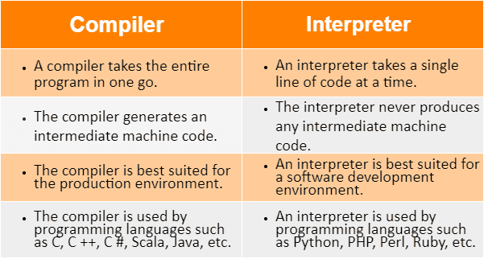

Q 3. Explain various important data structures used in two-pass assembler.

Ans:- Assembler algorithm as well as data structures are the different data structures used in two pass assembler.

These are simple assembler uses two major internal data structure.

Even the operation code table (optab) as well as the symbol table (symtab).

On the other hand optab is used to look up mnemonic operation codes as well as this will translate them to their machine language equivalents.

Q 4. Explain Multi Pass Assembler.

Ans;

• Multipass assembler means more than one pass is used by assembler.

• Multipass assembler is used to eliminate forward references in symbol definition.

• Forward References Problem - The assembler specifies the symbols should be declared anywhere in the in the program.

• There may be a chances of using a symbol before its declaration which gives rise to a forward reference problem.

• Due to this problem assembler won’t be able to assemble the instruction and such a problem is called forward references problem.

• The solution for forward references problem is having an assembler of two pass.

Q 5. Differentiate between Two-Pass Macro Processors & One-Pass Macro Processors.

